Tiogiva® Inhaler Switch

Please note that this document has not been updated for the 2026-27 incentive scheme. Standard Operating Procedures (SOPs) for medicines optimisation switches/reviews, along with other supporting materials, were originally developed for use by Medicines Optimisation Team staff within NHS South Yorkshire Integrated Care Board (ICB). Other organisations or groups choosing to use this resource does so at their own risk and NHS SY ICB accepts no liability for its use or application.

Bottom line:
Patients over 18 years of age who receive a prescription for tiotropium (Spiriva®) 18 microgram inhalation powder with handihaler device or tiotropium (Braltus®) 10microgram inhalation powder with Zonda® Inhaler (or generic equivalent) can have an alternative brand Tiogiva 18mcg inhalation powder capsules and Inhaler.

Launch Date: QIPP 25/26
Practices: All

Pharmacists and Pharmacy Technicians undertaking this action sheet should work within their clinical competence. Where appropriate please read in conjunction with appropriate referenced documents, the BNF and the relevant summary of product characteristics. If you are unsure, please speak to your line manager or one of the clinical leads.

Background /Evidence base
Tiogiva® is indicated as a maintenance bronchodilator treatment to relieve symptoms of adult patients 18+ with COPD. It contains tiotropium bromide as an inhalation powder, taken as clear capsules with the Tiogiva dry powder capsule inhaler, and has demonstrated bioequivalence with Spiriva®^{1.2}. Inhalation characteristics/technique of COPD patients through the Tiogiva inhaler were equivalent to those via the Handihaler® and Braltus® Zonda®
All of the capsules for inhalation provide a delivered dose of 10mcg of tiotropium however the way they are documented may differ. Spiriva® and Tiogiva® display the amount of tiotropium in the capsule (18mcg) however Braltus® is displayed as the delivered dose (10mcg)

For information:
Each Tiogiva® capsule for inhalation contains 18mcg of tiotropium. The delivered dose is equivalent to 10mcg of tiotropium.
Spiriva® capsules for inhalation also contain 18mcg of tiotropium, with a delivered dose of 10mcg of tiotropium.
Braltus® capsules for inhalation contain 13mcg of tiotropium, but the delivered dose is 10mcg of tiotropium.

Device
Tiogiva® inhaler with Tiogiva® 18mcg capsule for inhalation looks like this:
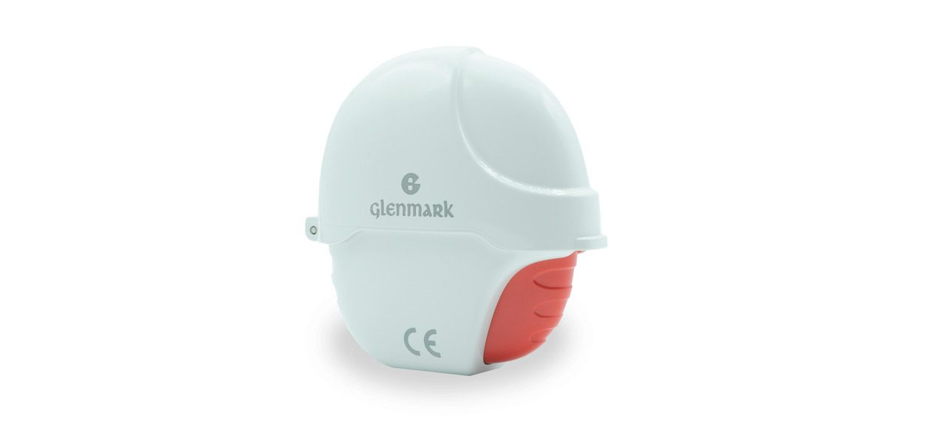
Image provided by Glenmark Pharma
- As previously mentioned, inhalation characteristics/technique of COPD patients through the Tiogiva inhaler are equivalent to those via the Handihaler® and Braltus® Zonda®.
- There is no need for patients to change inhaler technique when switching from another LAMA capsule inhaler.
- The capsules are clear which helps patients see immediately when a full dose has been taken. NB Patients can be advised to inhale a second time from the same capsule in order to empty the capsule completely.
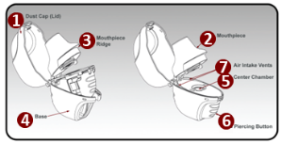 Image provided by Glenmark Pharma
Further information including a video showing how to use Tiogiva® can be found here - https://tiogiva.co.uk/hcp/
Tiogiva® is available as capsules with device or as capsules alone. The cost of 30 capsules is £19.20 so there is no significant additional saving to made by prescribing capsules alone. However, by not replacing the device each month waste plastic could be reduced. For the purpose of our switch programme we will be switching to capsules and device. The device must be replaced 6 monthly if not issued every month.

Patients using single long-acting muscarinic antagonist (LAMA) therapy

The Sheffield COPD algorithm developed jointly between STH and SY ICB Sheffield Place does not have a place for single LAMA therapy. This is because giving patients maximum bronchodilation early in the disease management improves patient outcomes. These patients should be switched, as per this action sheet to Tiogiva® and then referred to the practice for review to consider a LABA/LAMA combination device in line with the COPD algorithm. (LABA = long-acting β agonist)

Patients using LAMA and LABA as separate devices (no inhaled corticosteroid (ICS))

The Sheffield COPD algorithm advocates the use of combination LABA/LAMA inhalers for patients using LAMA and LABA without ICS. If you identify any patients using these agents as separate devices please switch to Tiogiva® if appropriate and refer to practice for review to consider a LABA/LAMA combination inhaler. (NB if switch subsequently occurs to LABA/LAMA inhaler this will be an additional cost-saving)

Patients using open triple therapy for COPD only

Patients with open triple therapy in COPD using Relvar® Ellipta® 92/22 and tiotropium or Fostair MDI 100/6 and tiotropium are covered by the closed triples action sheet. Consider a potential switch to closed triple if appropriate.

Please note that only Relvar® 92/22 and Fostair® 100/6 are licensed in COPD. The higher strength products have a licence for asthma only. If a patient is taking the higher strength Relvar 184/22 or Fostair 200/6 for COPD only then please switch their tiotropium as per the action sheet and refer the patients to the practice for review and possible step down to the lower licensed strength.

For any other open triple therapy in COPD only no asthma i.e. any ICS/LABA plus separate LAMA please highlight the patient to the practice for a potential review to change to an appropriate closed triple therapy.
Exclusion category

Please exclude the following patients from the switch and consider GP referral or review with the respiratory nurse where appropriate:

- Pregnancy and breast-feeding
- Documented intolerance to Tiogiva® Inhaler
- Hypersensitivity to tiotropium or any of the excipients in Tiogiva® Inhaler.
- Any further contraindications to tiotropium (see SPC).
- Patients with only asthma no COPD – consider change to Spiriva® Respimat® which is the licensed product for use in asthma. (Change of device therefore this would need to be done face to face with the patient)
- Patients reporting any worsening of cardiac symptoms after starting tiotropium. (this includes but is not limited to arrythmias, palpitations etc). This is unlikely as patients would have most likely had the tiotropium stopped but it is important to be aware of this.
- Serious interaction with tiotropium and another prescribed medication.(check BNF/SPC)
- Patients under 18 years of age
- Patients with conditions that may be affected by the anticholinergic action of tiotropium, including:
- Myocardial infarction in the last six months,
- Unstable or life-threatening cardiac arrhythmia,
- Cardiac arrhythmia requiring intervention or a change in drug therapy in the past year,
- Hospitalisation for heart failure (NYHA Class III or IV) within the past year

These patients should be referred to GP/nurse for face-to-face review and or switch.

Special considerations

- Patients with eGFR< 50 ml/min – please check there has been no deterioration in renal function since commencing tiotropium. If renal function is stable it is appropriate to switch these patients since they are already using tiotropium. Once switched highlight these patients for consideration to use an alternative LAMA inhaler at next review. A suitable inhaler choice is Incruse® Ellipta® 55mcg/dose dry powder inhaler (umeclidinium) which is hepatically metabolised.

- Patients with narrow-angle glaucoma, prostatic hyperplasia or bladder-neck obstruction. As these patients are already using tiotropium, they will be ok to switch, however please highlight to the practice in case it is felt the patient should be reviewed for the suitability of a LAMA inhaler. Dr Rod Lawson has previously stated that these are theoretical problems with any antimuscarinic. He has previously tried withholding LAMA in patients with prostate issues and it hasn’t made a difference. He has never come across a problem with glaucoma. He thinks there is a risk that a patient would have a decent drug withheld without benefit in return rather than a risk of side effects being encountered.

Lactose content – Tiogiva contains lactose monohydrate (which may contain small amounts of milk proteins). This is also present in both Spiriva Handihaler and Braltus Zonda therefore this should not impact on the switch.

Communication to patients

This switch must be done via letter either by post or via Accurx and the patient must receive a copy of the leaflet. Right hand side note is not appropriate for this switch.
Additional support documents have been produced to support switching via Accurx.

Action required

Action required | By
- Discuss and gain agreement with the prescribing lead GP. Please inform line manager if any barriers to carrying out the work. | Pharmacist/Technician
- Liaise with the community pharmacy where appropriate. | Pharmacist/Technician
- Run searches within your practice to identify:  Patients currently using Spiriva Handihaler  Patients currently using Braltus Zonda  Patients currently prescribed generic tiotropium dry powder capsule inhalers  (see also exclusion criteria) | Pharmacist/Technician
- Carry out agreed actions and communicate to the patient in the agreed manner.  Where patient resides in a care home communicate changes using communication sheet (Appendix 4). | Pharmacist/Technician

References

1. Tiogiva Summary of Product Characteristics https://www.medicines.org.uk/emc/product/12556/smpc#gref

Appendix 3
PRACTICE ADDRESS
LIST OF GPs ETC
Private and Confidential

PATIENT NAME / ADDRESS NHS Number:

DATE

Dear

Your doctor has agreed a change to your prescription medication

Prescribing at the practice is regularly reviewed to make sure patients are receiving the most suitable and cost-effective medication.

At the moment you use Spiriva Handihaler device and inhalation capsules/Braltus Zonda device and inhalation capsules (delete as appropriate)
This has been changed to Tiogiva device and inhalation capsules containing the same medication called tiotropium

These inhalers contain the same medication so work in the same way and are equally effective but Tiogiva device and inhalation capsules is available at a lower cost to the NHS. This means that the savings made by prescribing this instead of Spiriva Handihaler device and inhalation capsules/Braltus Zonda device and inhalation capsules (delete as appropriate) can then be used to support and improve other NHS services.
Please note:

- The change will not affect the way your condition is managed; you will continue to be monitored by your doctor as before.
- Your next repeat prescription will be changed to Tiogiva device and inhalation capsules. Please continue to use your current supply of Spiriva Handihaler device and inhalation capsules/Braltus Zonda device and inhalation capsules (delete as appropriate) as prescribed by your doctor until the pack is finished and you collect your new prescription.
- The new inhaler Tiogiva device and inhalation capsules. should be used in exactly the same way as your old brand of medication. Do not use both together.
- Please read the patient information leaflet provided with the new medication.
- This letter only refers to the change to Spiriva Handihaler device and inhalation capsules/Braltus Zonda device and inhalation capsules (delete as appropriate) . All your other medication should be taken as prescribed by your GP.
I hope you are happy about the reasons for this change. If you have any concerns or notice any changes in your condition please contact the surgery.

Yours sincerely,

Appendix 4

