Change of inhaler brand from Braltus Zonda to Tiogiva
- Your Braltus Zonda inhaler has been changed to the brand Tiogiva.
- This inhaler works in the same way as Braltus Zonda and contains the same medication (tiotropium). You will receive the same amount of medicine per dose even though the strength on the label may look different.
- The new device is white and red. It is opened in the same way as Braltus Zonda by lifting up the lid, followed by lifting up the mouthpiece to show the centre chamber, place a capsule in the centre chamber then close the mouthpiece so that it clicks shut. Press the button on the side of the device once to pierce the capsule. The dose is now ready to inhale using exactly the same technique that you are used to.
- Do not put the capsule directly into the mouthpiece. It must go into the centre chamber by lifting up the mouthpiece.
- The capsules for Tiogiva will come in a blister pack.
- There is a leaflet also attached which shows you how to use Tiogiva
- Further information including a video demonstration of Tiogiva can be found at https://tiogiva.co.uk/patient/
- You should notice no difference in the management of your condition.
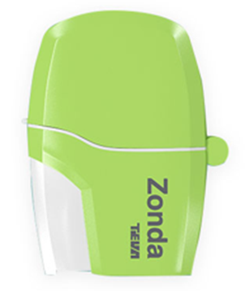
Your current inhaler looks like this:

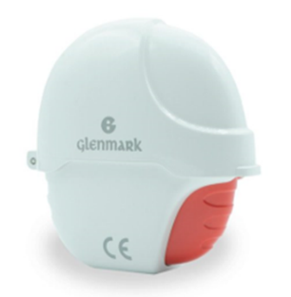

Your new inhaler will look like this:

